|  |  |
| --- | --- |
| **Module:** | ST2053 |
| **Name:** | Marcus Prunty |
| **Student Number:** | 118730509 |
| **Chapter:** | 3 |

**Maximum 2 pages! Do not delete the page number in the footer.**

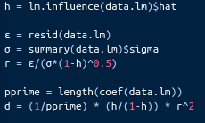

**Calculate the following for each case:**

**the residuals (e), the studentized residuals (r), leverages (h) and Cook’s distances (d).**

**(a) By how much does the model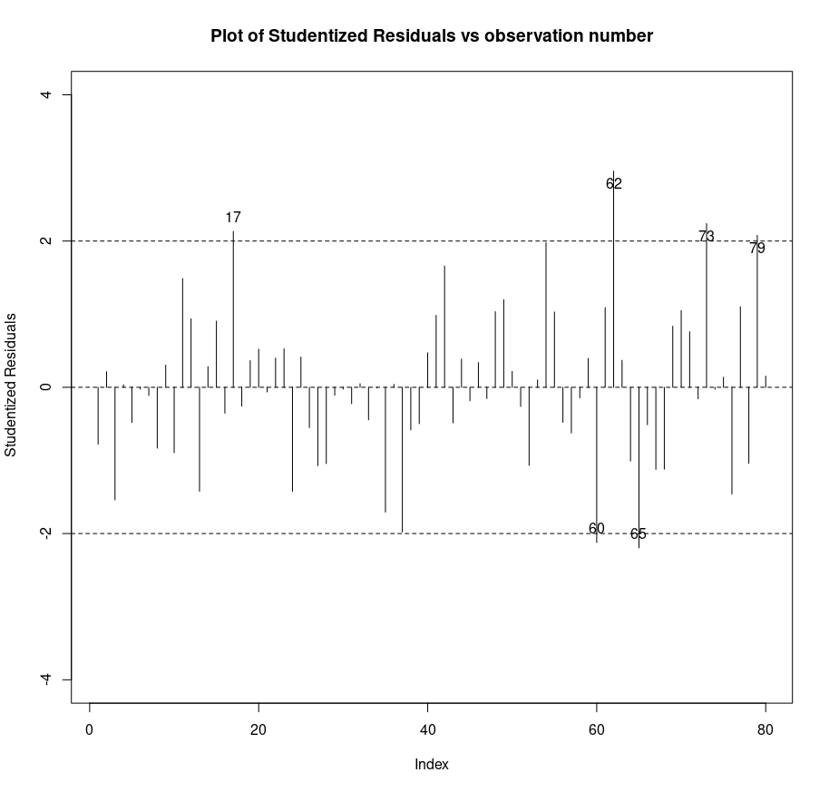 under/over-estimate BMI for case 1? (5 marks)**

The model overestimates the BMI for case 1 by -1.2442



**(b) Providing a suitable plot, identify which cases are outliers. Quote the value of the studentized residual for the most extreme case. (10 marks)**

Cases 17, 60, 62, 65, 73 and 79 are outliers i.e standardised residuals >|2|.

The most extreme case is 62 = 2.9555



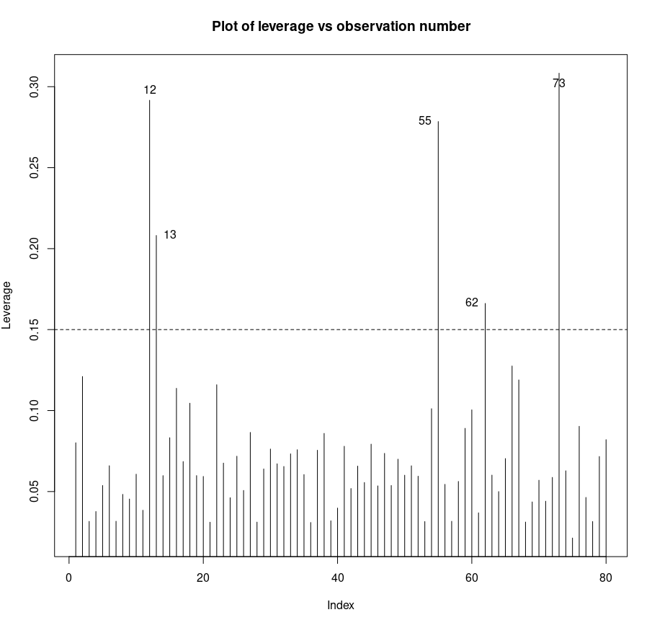

**(c) Providing a suitable plot, identify which cases are of high leverage. Quote the**

**value of leverage for the most extreme case. Explain precisely why this case is of**

**high leverage. (15 marks)**

12, 13, 55, 62 and 73 are the cases of High leverage

73 is the most extreme at 0.3083 considerably higher than . BMI, Waist, Elbow, Arm are all above Q3, while wrist is just above the mean and Leg = minimum

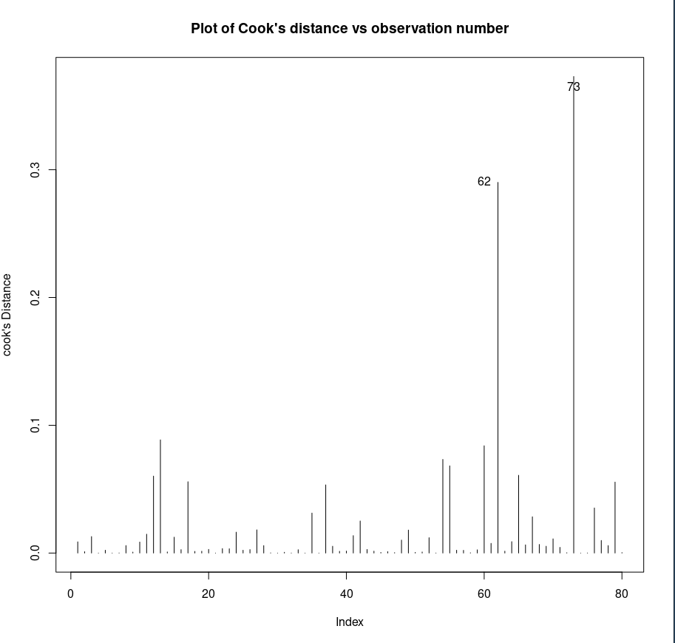

**(d) Provide a suitable plot of Cook’s distances. Interpret this plot and explain any cases you identify. Quote the Cook’s distance for the most extreme case. (10 marks)**

62 and 73 have high influence

Case 62 is an outlier (ri=2.9555 > 2) and has high leverage (hii=0.1662 > 0.15)

Case 73 is an outlier (ri=2.2405 > 2) and has very high leverage (hii=0.3083> 0.15)

Cooks number for 73, Di=0.3730



**(e) Based on the above analyses, what recommendation(s) would you make for this**

**model? Explain. (10 marks)**

Investigate case 62 and 73.

Case 62 is the most extreme outlier and 2nd most influential

Case 73 has the highest leverage and is the most influential